Email Protocols
One of the primary services offered by an ISP is email hosting. To run on a computer or other end device, email requires several applications and services, as shown in the figure. Email is a store-and-forward method of sending, storing, and retrieving electronic messages across a network. Email messages are stored in databases on mail servers.
Email clients communicate with mail servers to send and receive email. Mail servers communicate with other mail servers to transport messages from one domain to another. An email client does not communicate directly with another email client when sending email. Instead, both clients rely on the mail server to transport messages.
Email supports three separate protocols for operation: Simple Mail Transfer Protocol (SMTP), Post Office Protocol (POP), and IMAP. The application layer process that sends mail uses SMTP. A client retrieves email, however, using one of the two application layer protocols: POP or IMAP.
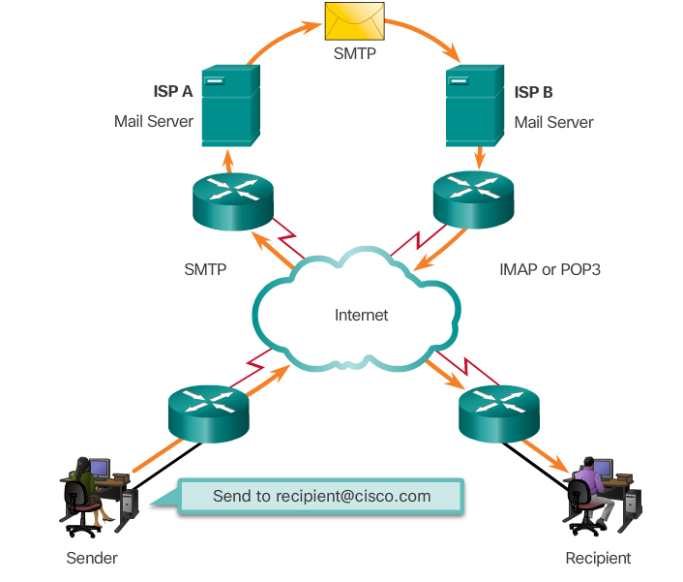
ISP – Internet Service Provider Protocol for SENDING emails
SMTP – Simple Mail Transfer Protocol Protocol for SENDING emails
IMAP – Internet Message Access Protocol Protocol for RECIVING email
POP – Post Office Protocol Protocol for RECIVING email
EXERCISES:

- What is an e-mail? Where are emails stored?
- What protocols are used for sending emails?
- What protocols are responsible for receiving email?
- Write the abbreviations
ISP –
SMTP –
IMAP –
POP –
- Describe the picture.

